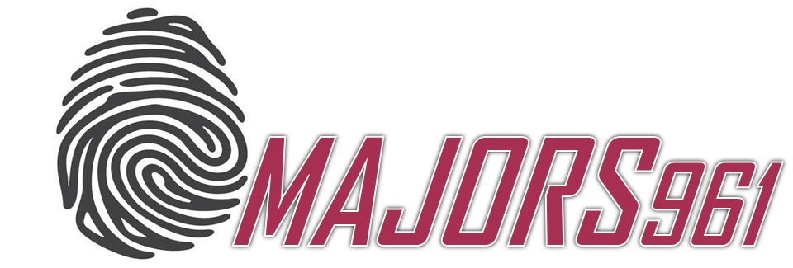

* ***Objective:*** Final Project
* ***Date:*** 15/12/2019
* ***Students:*** Hadi Abdelmajid
* ***Introduction:*** Our website aims for gaining students with guidance in order to be able to choose their suitable major and university in Lebanon. For them to have a successful career.
* ***Goals:***
  + Our goal is striving to make sure that every student in Lebanon is getting enough guidance in order to make sure they are studying what they truly love.
  + Our goal is reaching a level where all men and women in Lebanon are working and benefiting the society in the areas they love and exploring the career they always dreamt about.
* ***Logo:***



* ***Home page:*** It is the landing page were the user will have an overview about our website’s idea and get attracted through reading the questions he’s thinking about on our page where he will feel that we know his thoughts and we need to clarify his misconceptions.
* ***About page:***Through the About page we will be informing the user about the website developers and what is the goal behind developing this website. In addition to that while overviewing this page, the user will gain an idea about the background of the developers and should he/she take their lead.
* ***Majors page***:Through this main page, the user will be able to access the most important universities in Lebanon, have an idea about the majors available in it and their fees in addition to getting linked to each university’s website.
* ***Contact page:*** Our website will always be ready to help the user and guide him to what he aims for. For that reason, the Contact us page is extremely important in which the user will have the chance and the access for a private consultation.
* ***How to improve this platform?***
* This platform should communicate more with the user in which we are offering guidance and for that to happened we should lead the user.
* This platform should access all the universities in Lebanon.
* This platform should include more information about the universities and majors.